**Internal release Note – JIT number 12508 – Link between the Certificate and Inspection Modules**

1. **Introduction**
   1. The document communicates the major new features and changes in this release of Survey certificate and Inspection module of JiBe. It also documents menu changes and access rights.
2. **About this release**
   1. Linking between two independent modules Survey certificate and inspection module.
   2. Inspection can be created for Survey certificate through Inspection calendar and survey certificate detail module.
   3. New two icons (Red and Yellow color box) of survey certificate in inspection calendar module.
3. **New Features**
   1. Linking/creating new inspection for survey certificate from inspection calendar and survey certificate detail page.
   2. Merged Survey certificate, Survey category, Certificate authority, Survey document type, N/A survey and certificates and Survey vessel assignment admin pages into new Survey and Certificate Settings admin page.
   3. Survey certificate can be marked as Inspection required in survey certificate admin page.
   4. Delete feature is added in survey certificate details.
4. **Menus / Access Rights added or removed**
   1. Survey and Certificate Settings screen

Description: For current users having access to survey certificate page by default will have access to new Survey and Certificate Settings page.

Path : Technical > Admin > Survey and Certificate Settings

URL : Surveys/SurveyandCertificateSettings.aspx

Enable Access:

* *Access_View: To view survey certificate admin pages.*



1. **Improvements/Enhancements**
   1. **Survey Certificate admin page**:
      1. Individual survey certificate can be marked as Inspection required from add/edit survey certificate page admin page and it will be reflected in the survey certificate detail page

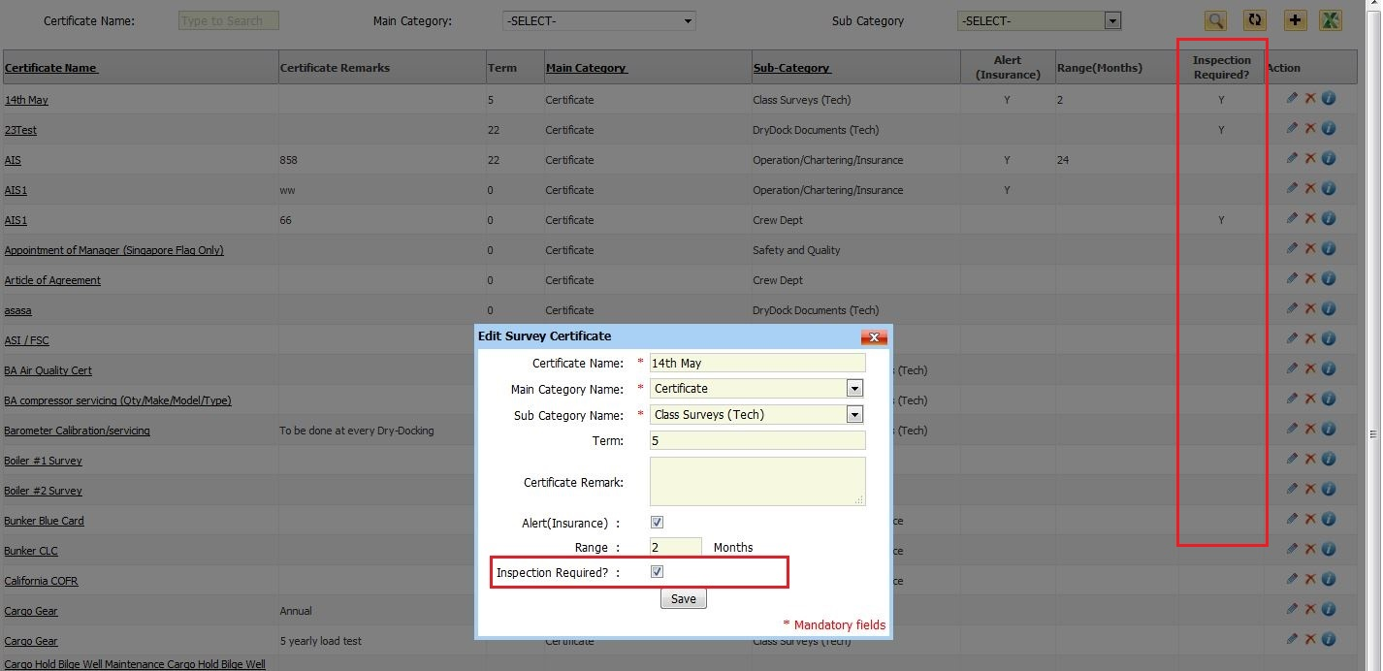

* 1. **Survey Index page:**
     1. Default Issue and Expiry from date is set to 01/01/1900 to 01/01/1990 in filters.
     2. Show all check box is moved under Expiring In block.

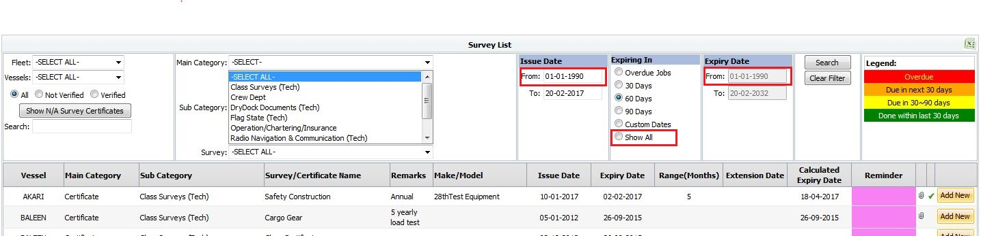

* 1. **Survey Details:**

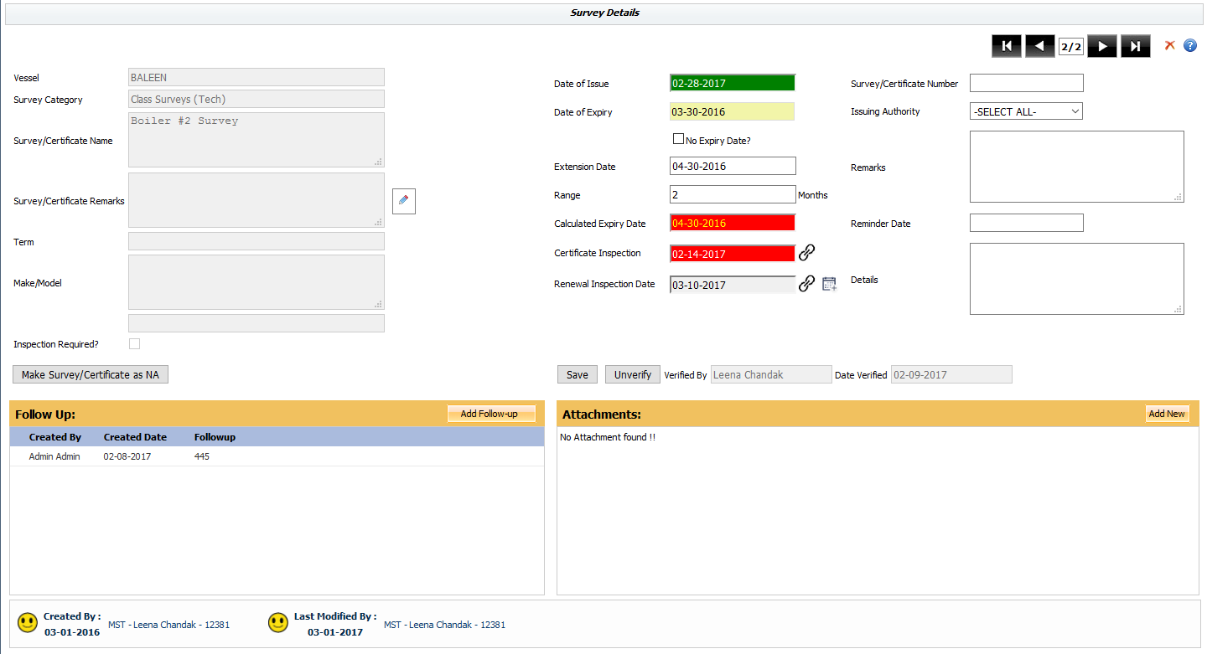

* + 1. Added feature to delete particular certificate(only who have ‘Admin’ rights)
    2. Only Verified Inspections will sync to vessel
    3. Added 3 new fields

Inspection Required: Which will be checked or unchecked depending on Survey Certificate page

Certificate Inspection: will refer to the inspection that was done in order to receive the current certificate

Renewal Inspection: will refer to the inspection that is scheduled in order to receive the new certificate

* + 1. Highlighting the inspections(Certificate Inspection & Renewal Inspection)

If the inspection is overdue, highlight it in red

If the inspection is completed, highlight it in green

* + 1. Added 2 icons

: Clicking this icon will open “Schedule new inspection” window , to schedule new inspection and link to Renewal Inspection



 : Clicking this icon will open a popup with already created inspection

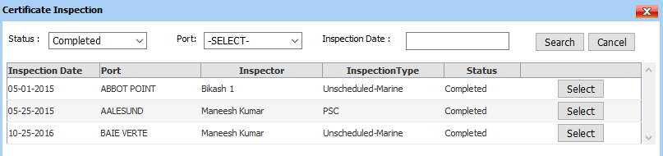

* 1. **Inspection Calendar:**
     1. Two new icons (red and yellow with inspection image) for survey certificate vessel wise will be displayed on calendar.
     2. Red icon will be displayed according to the calculated expiry date of survey certificate.
     3. User can create inspection for survey certificate from the popup. Once the new inspection is created then new date will be reflected in popup next to Renewal Inspection field and inspection icon will be disabled. User can navigate to newly created inspection by clicking on date next to renewal inspection field.



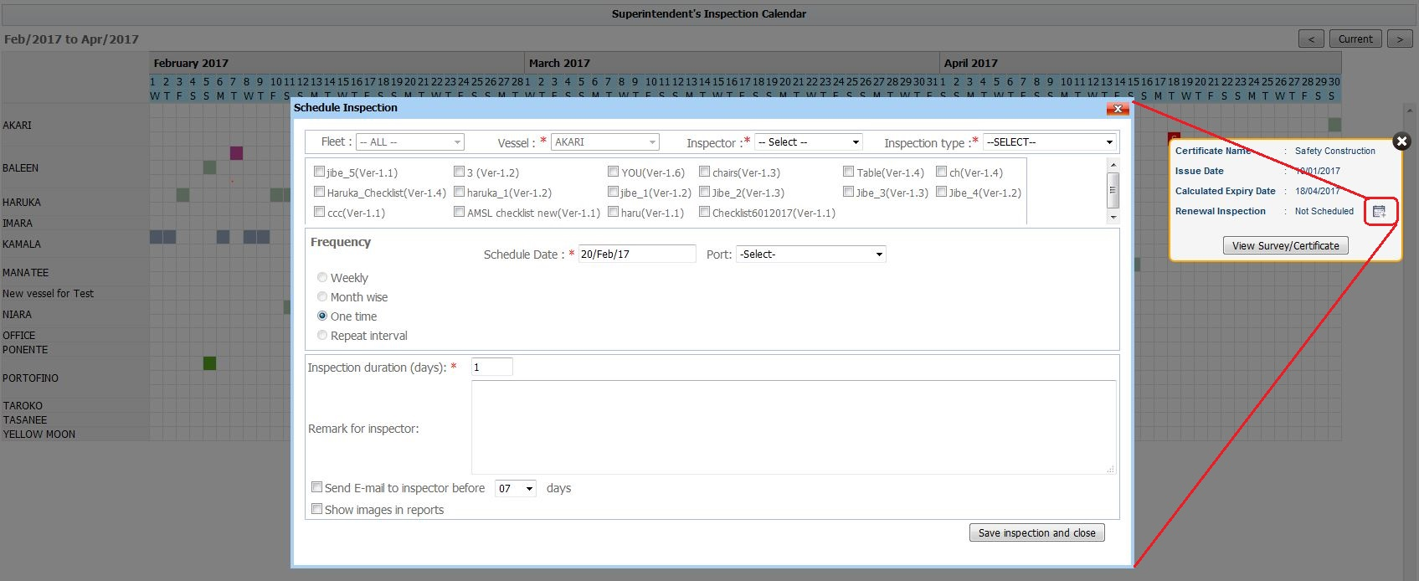

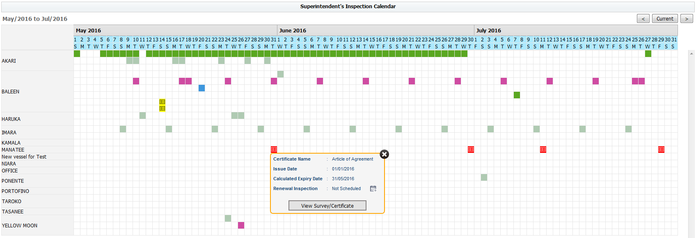

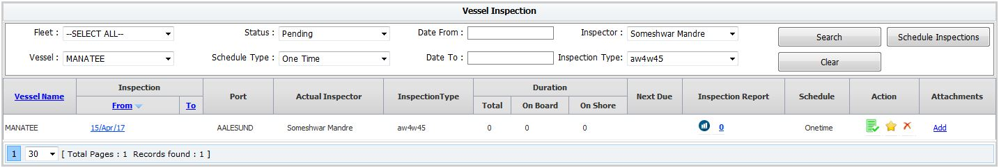

* + 1. Yellow icon will be displayed according to the reminder date of survey certificate.

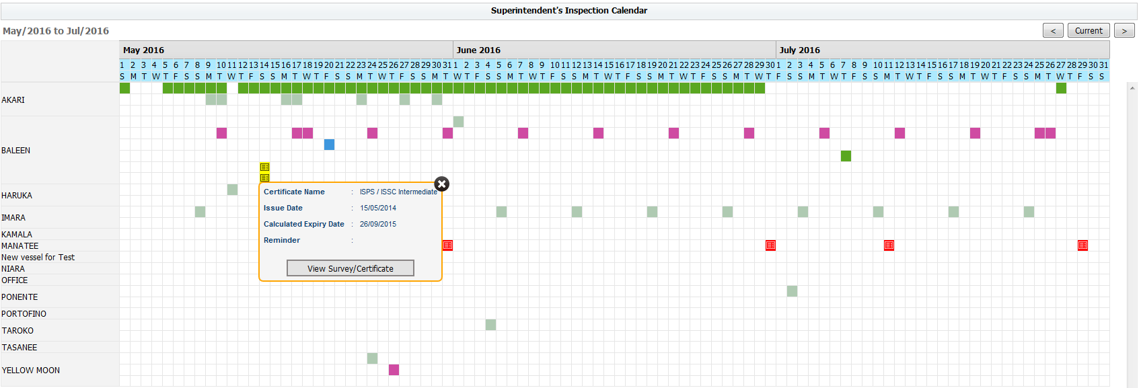

**5.5 Survey and Certificate Settings**

Merged Survey certificate, Survey category, Certificate authority, Survey document type, N/A survey and certificates and Survey vessel assignment admin pages into new Survey and Certificate Settings admin page.

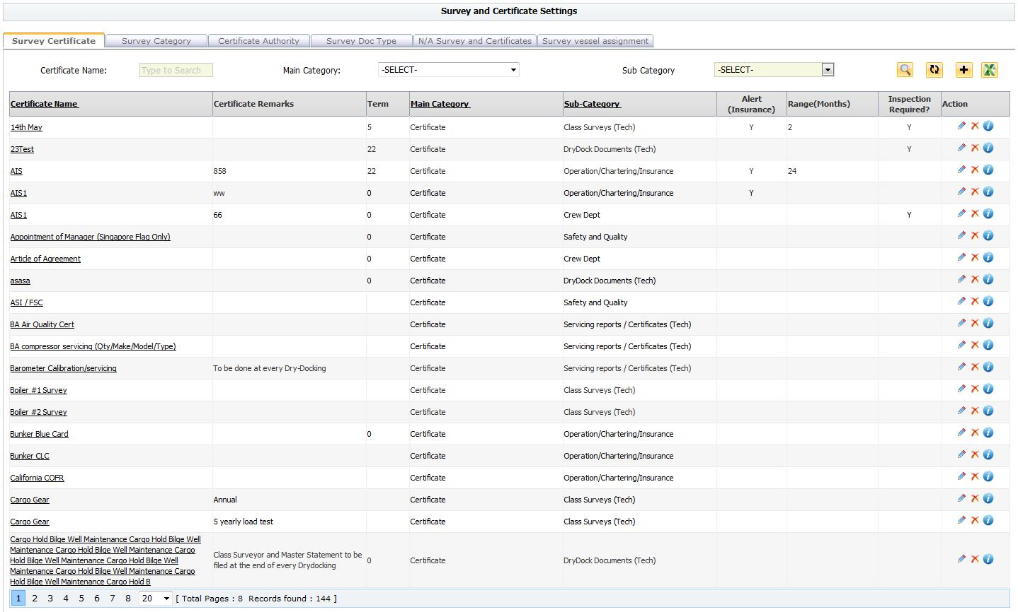

1. **Fixed Bugs**
2. **Known Issues**
3. **Retired or Removed features**
   1. Updated multi selection port list to single port selection while creating new one time inspection.